**BANKING ROYAL COMMISSION FACTIVA GUIDE**

**Current as at January 2019**



**1 FORWARD**

This Guide explains how to search for media sources on the topic of the Banking Royal Commission using Factiva. It was prepared to assist CLMR interns with the task of searching and exporting all media on the topic of the Banking Royal Commission within a particular date range.

**2 BACKGROUND INFORMATION**

Factiva is a news database produced by Dow Jones that provides access to a wide range of information from newspapers, newswires, industry publications, websites, company reports, and more.

**3 STEP-BY-STEP GUIDE**

***Accessing Factiva***

1. Open the following link on your preferred internet browser and ensure that you are signed in to UNSW myLibrary: https://primoa.library.unsw.edu.au/primo-explore/fulldisplay?vid=UNSWS&query=any,contains,factiva&docid=UNSW_ALMA61158502290001731&_ga=2.169876960.1936206791.1548803522-1204352424.1538523283
2. Click ‘Factiva – Dow Jones’:

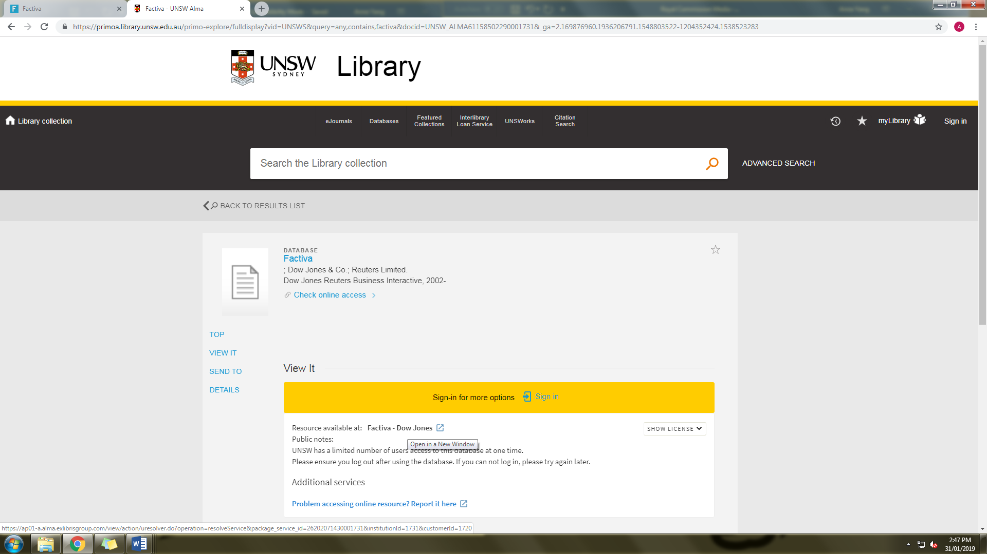

A new tab/window will open to the Factiva website:

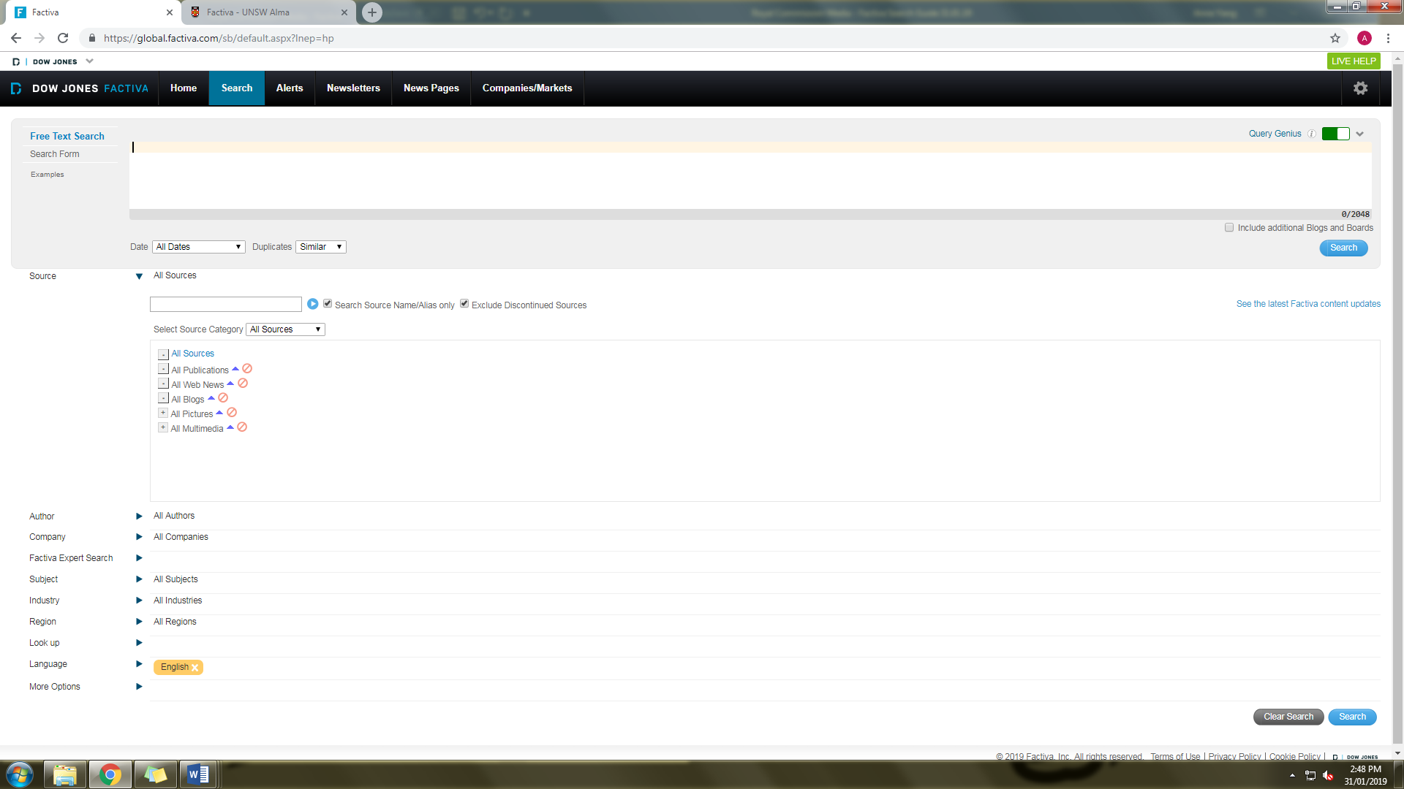

***Search parameters***

1. Select the search method ‘Search Form’:

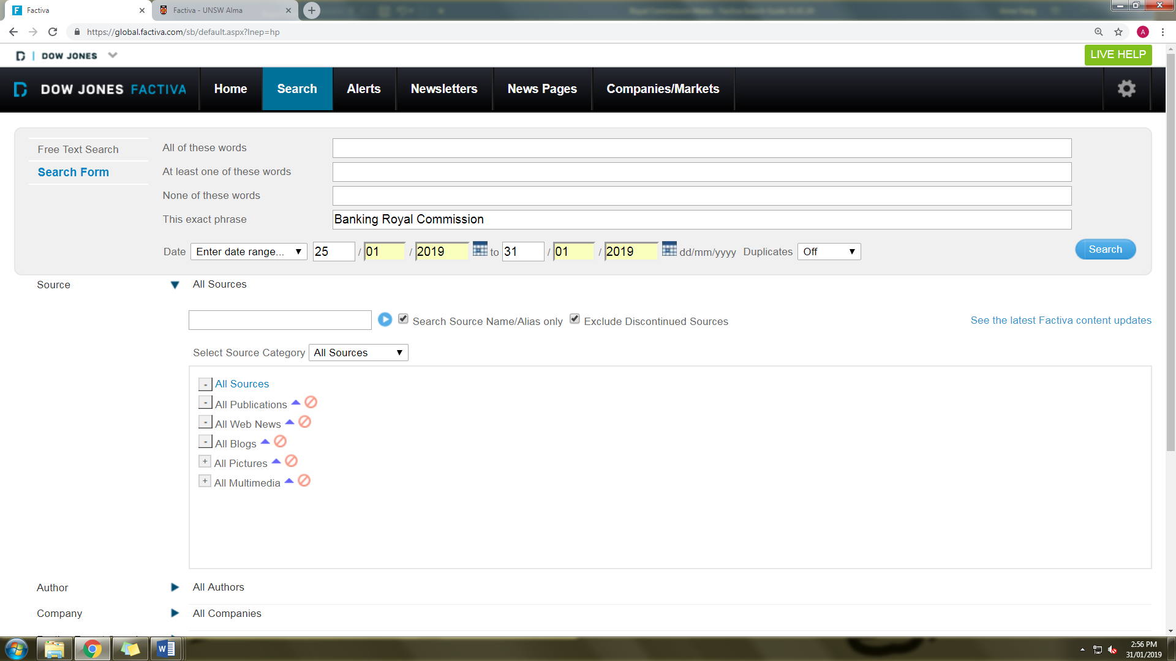

1. Enter into the search bar ‘This exact phrase’ the search term ‘Banking Royal Commission’:



1. Select your date range. To determine the start date, check the end date of the last folder of saved search results. Your start date is the following day. Your end date is the day before the day on which you conduct your search. For example if the most recently search was for 18/01/2019–24/01/2019 and you are conducting your search on 01/02/2019, the date range for your search would be 25/01/2019 to 31/01/2019. The reason we only search up to the day before the current date is so that the search has complete data up to the final day and we do not miss any records.



1. In the ‘Duplicates’ downbar, select ‘Off’, so that the search collects all media, including duplicated articles.

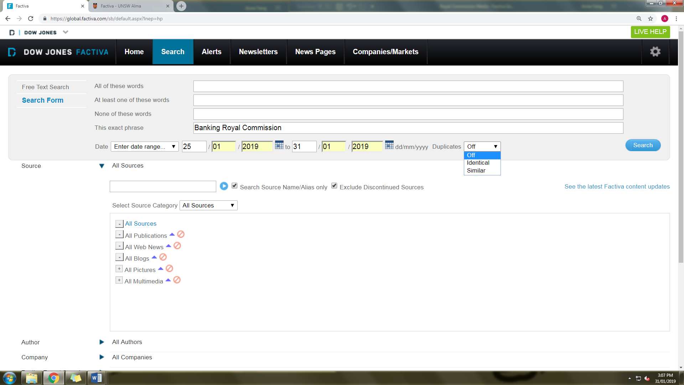

1. For Subject, exclude ‘Sports’, by clicking the red circle symbol next to Sports. Make sure the selection has been saved by checking that the grey and orange text bubbles appear as below.

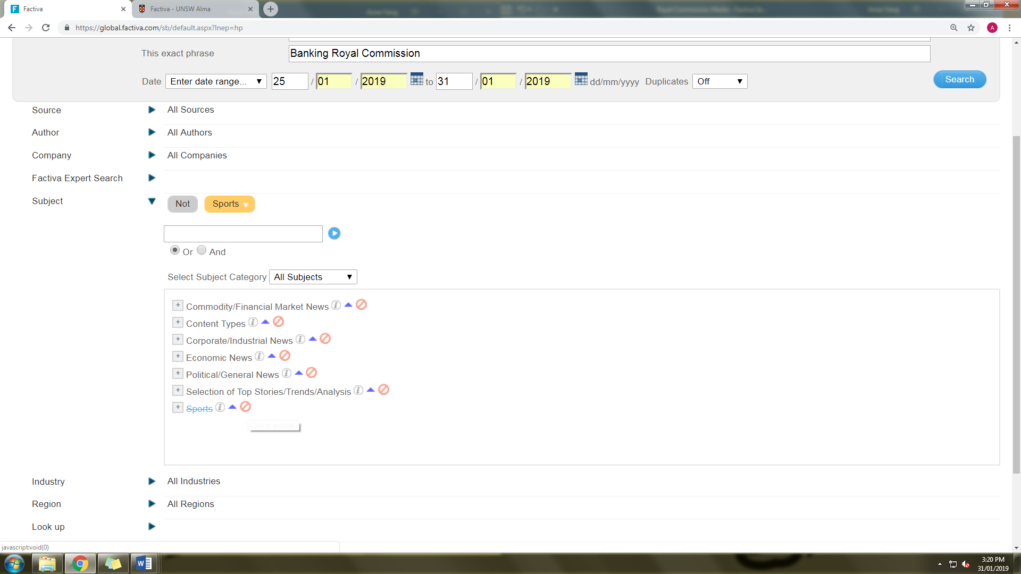

1. For Region, select ‘Asia Pacific’. An orange text bubble will appear once the selection has been saved.

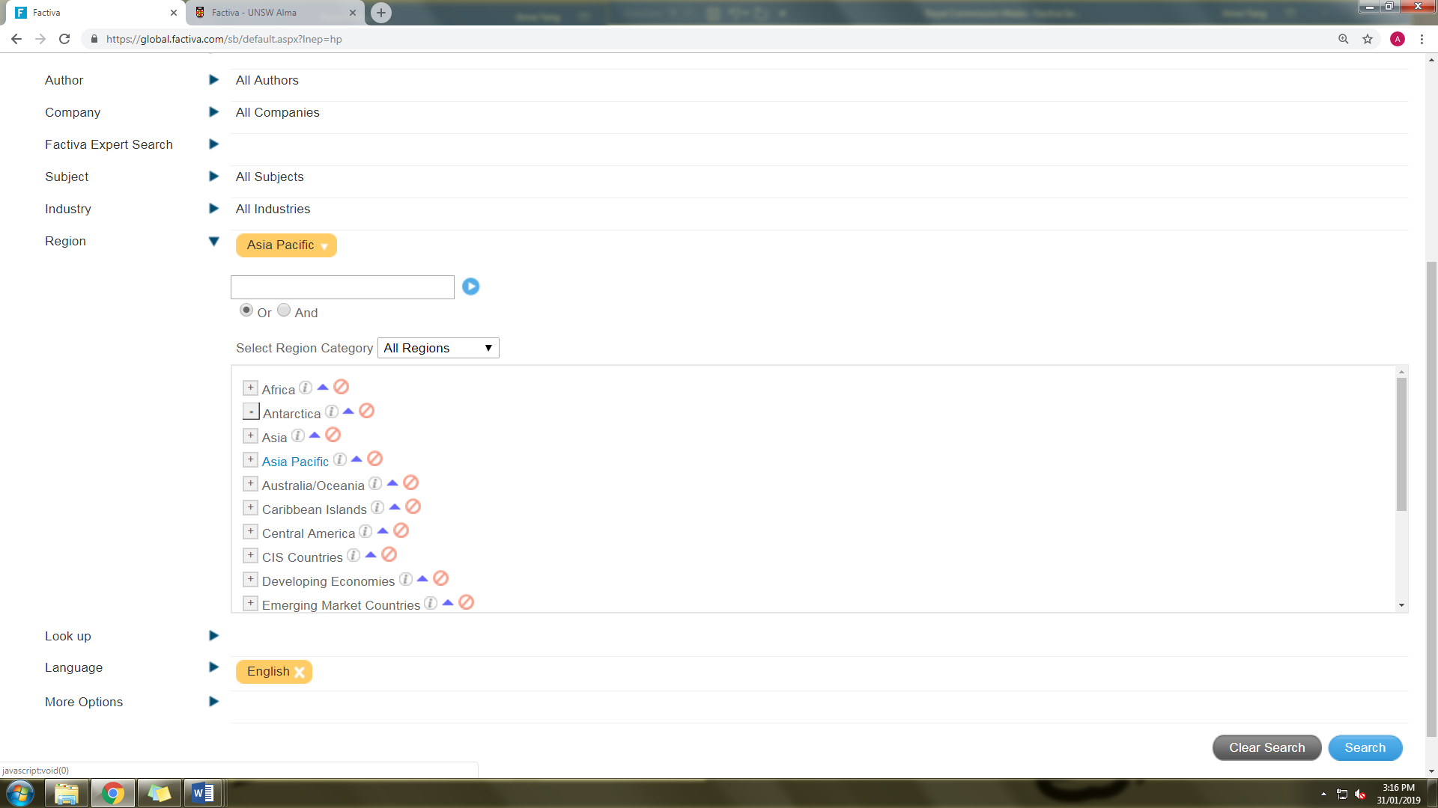

1. Run the search, by clicking the blue text bubble ‘Search’ in the bottom right hand corner of the webpage.

***Exporting search results***

1. Collect the summary statistics from the panel on the left hand side. So for each of the following:
   1. Date;
   2. Companies;
   3. Sources;
   4. Regions; and
   5. Executives

click ‘Export’, and download both the ‘Graph Image’ and Excel data (‘.CVS’).

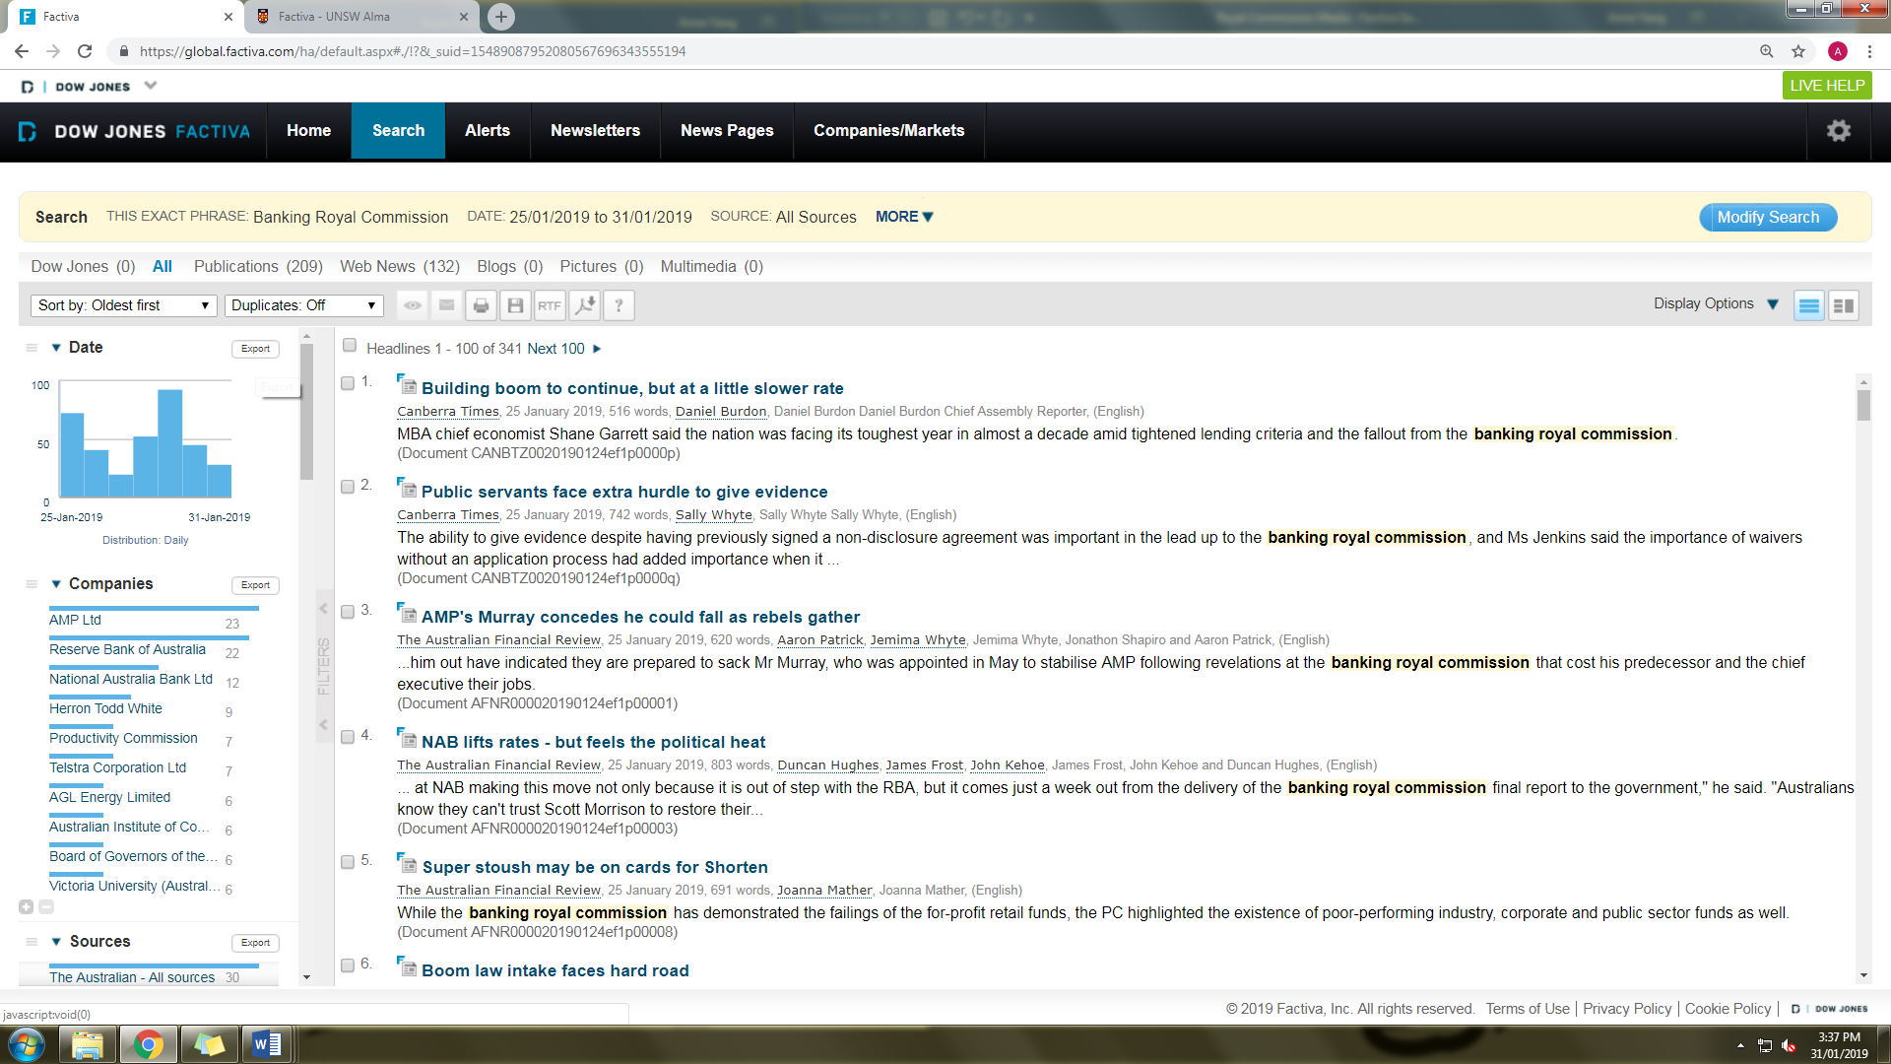

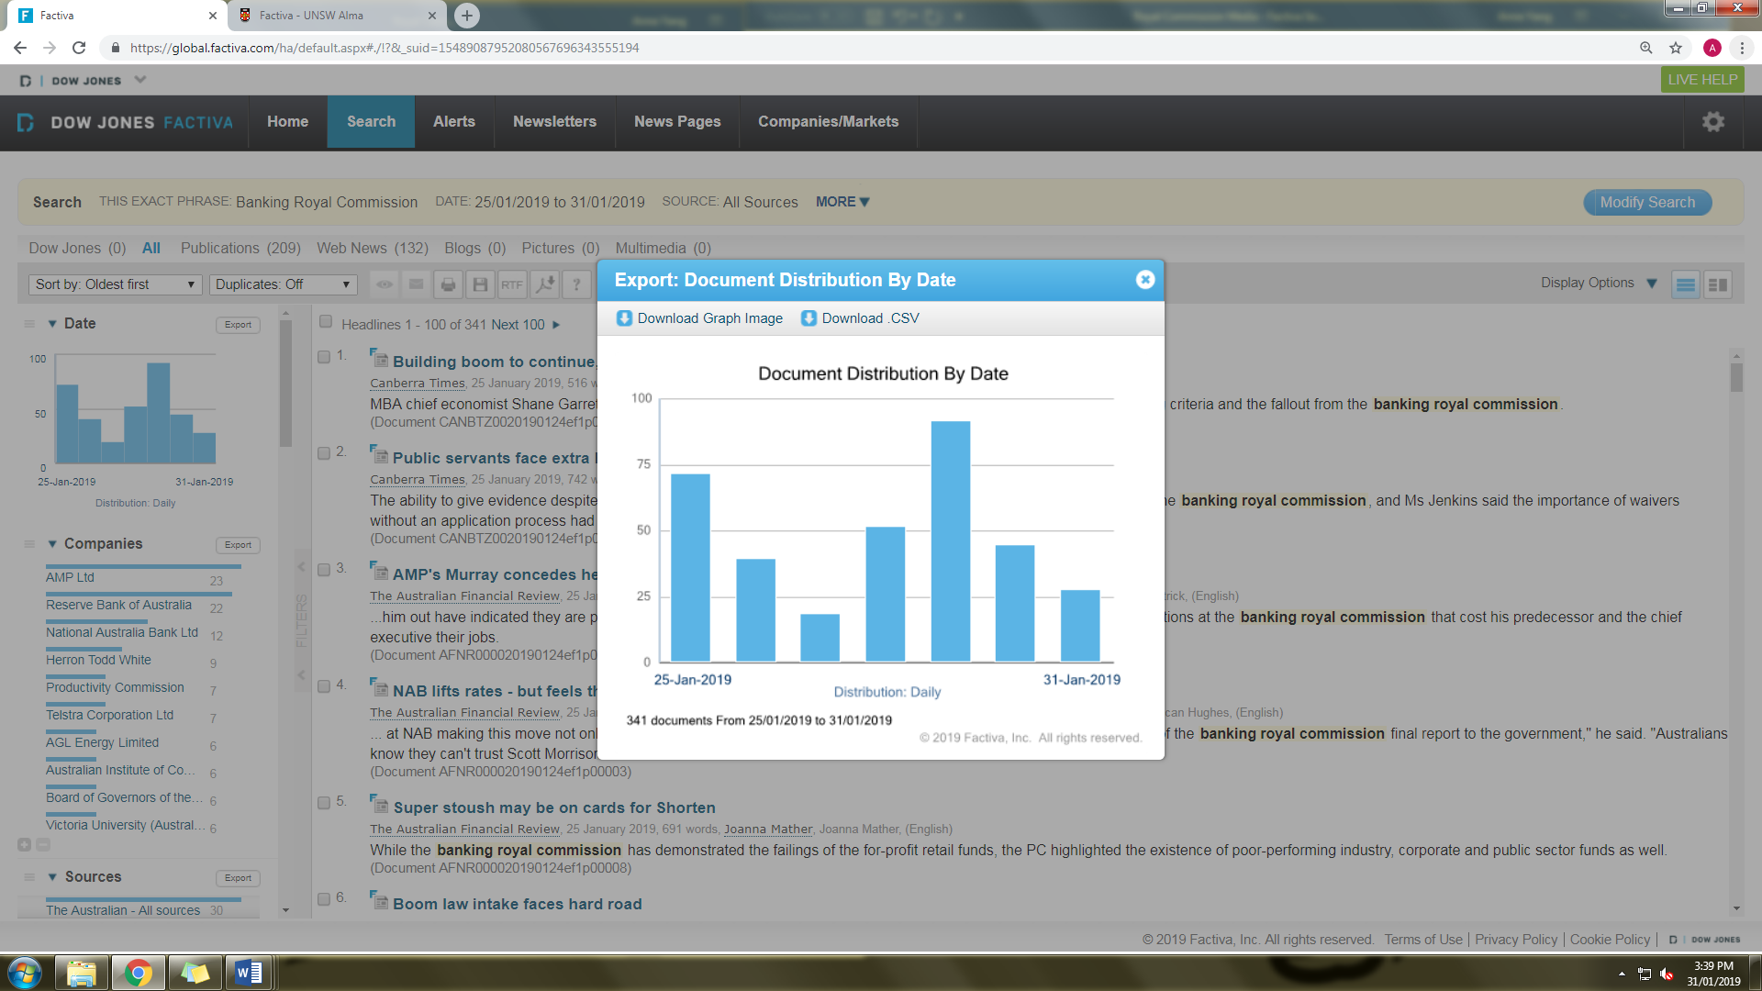

Rename each file in the following format: eg, DateChart, DateData, CompaniesChart, etc.

1. Select the first 100 articles by clicking the box circled below. Then download the selected articles in RTF format, by clicking the ‘RFT’ box and then clicking ‘Headline, Article and TOC’. The selected articles will save to the Downloads folder on your device.

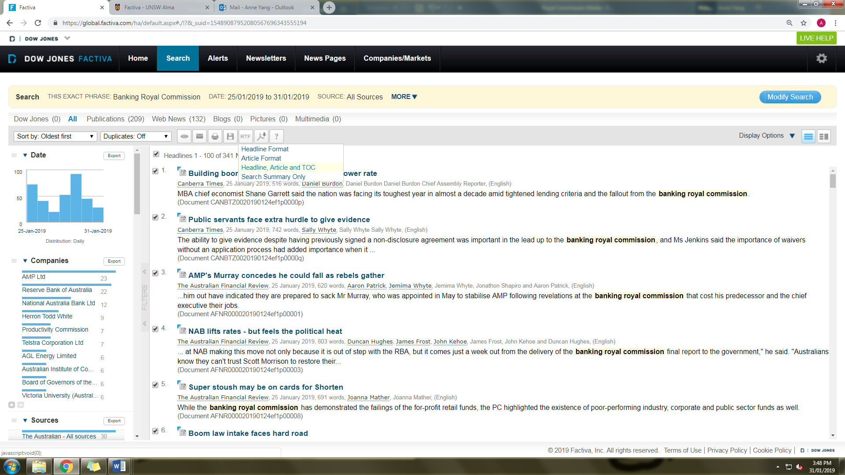

1. Repeat for the next 100 articles, the next 100 articles thereafter, and so on. For subsequent downloads, after clicking ‘Next 100’, you will need clear the previously selected articles and select the next 100.

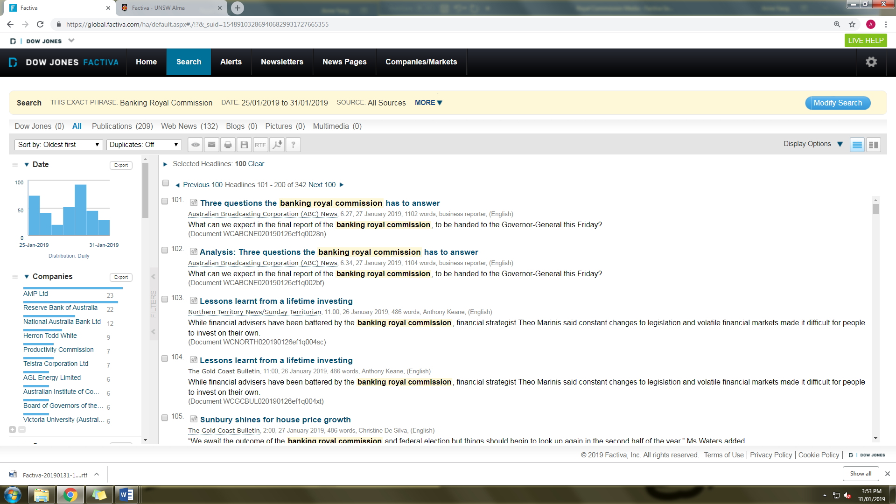

1. Rename each batch of downloads, by adding to the end of each name the following: “_1_100” for the first batch, and “_101_200”, etc. until all articles have been downloaded.
2. Ensure that all downloaded files are saved in the relevant folder in a sub-folder titled ‘BRC_media_[start date]­_[end date]’ (with dates in the following format: ddmmyyy) (eg, ‘BRC_media_25012019_3101019’).